COMPUTER ORGANIZATION AND ASSEMBLY LANGUAGE

TOPIC:
BASIC ARITHMETIC OPERATIONS

NAME:
MUHAMMAD TALHA
ROLL#:
241890
SECTION:
4/A

INSTRUCTOR:
Ms. ROMANA MAROOF

TASK 1:
Create a program to compare two values using CMP AND SHOW REGISTERS
CODE:
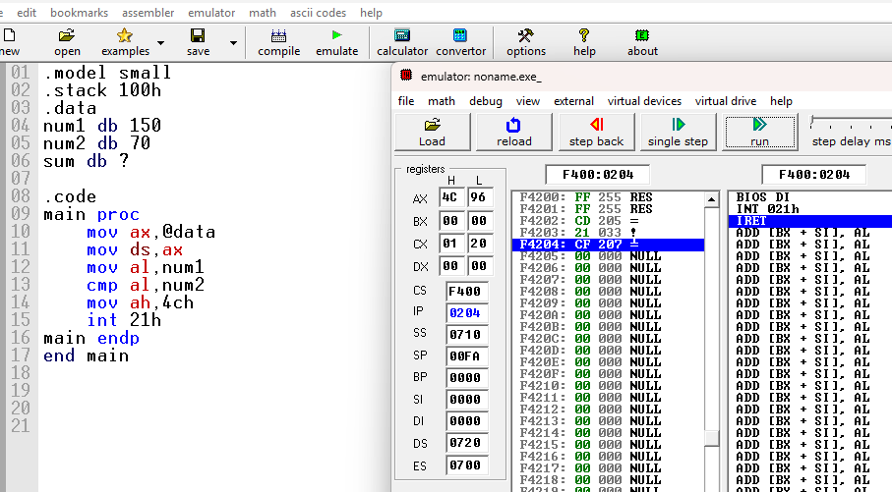
DEBUGGING:
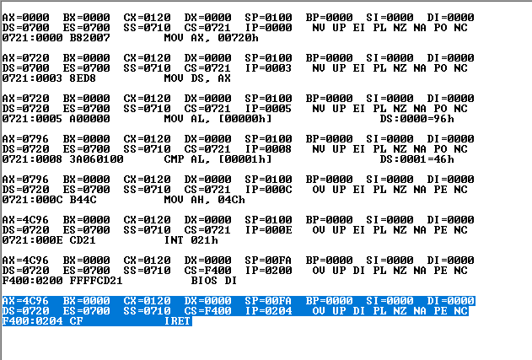

STEPS:
- load address of data segment into ax.
- initialize ds with data segment address
- copy num1 (150) into al.
- compare al (150) with num2 (70), update flags only.
- prepare dos terminate function.
- exit program.
EXPLAIANTION
- mov al, num1
  - al gets 150 (num1 value).
- cmp al, num2
  - al (150) is compared with 70; no register changes, only flags update
- mov ah, 4ch
  - ah gets 4Ch; now ax becomes 4C96h.
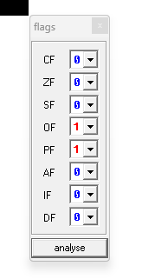
FALGS:
al gets value 150
150 is compared with 70 and flags update
flags become: zf=0 sf=0 cf=0 of=0 pf=1 af=0

TASK#2
ADDITION COMMANDS
CODE:
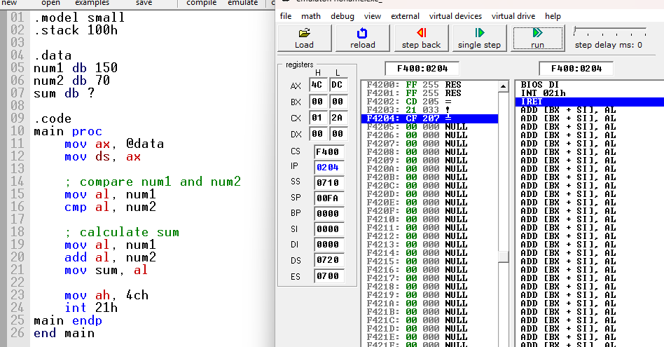
DEBUGGING (ONLY FOR SUM):
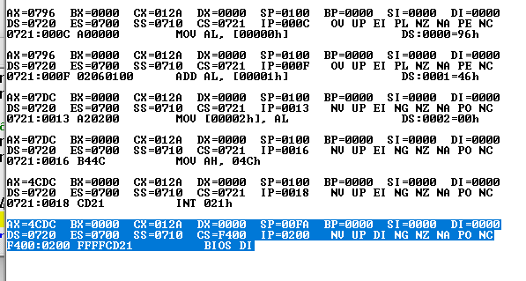

STEPS:
- Start of main procedure
- ax gets data segment address
- ds get value from ax
- al gets num1
- Compare al with num2, flags update
- al gets num1 again
- Add num2 to al => sum in al
- Store al into sum memory
- ah = 4ch to prepare exit
- Call interrupt 21h => terminate program

EXLAINATION:
• mov al, num1
o al gets 150 again to prepare for addition.
• add al, num2
al = 150 + 70 : al becomes 220.
• mov sum, al
o sum memory location gets value 220.

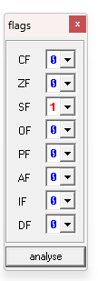
FLAGS:

TASK#3
SUBTRACTION CODE

CODE:
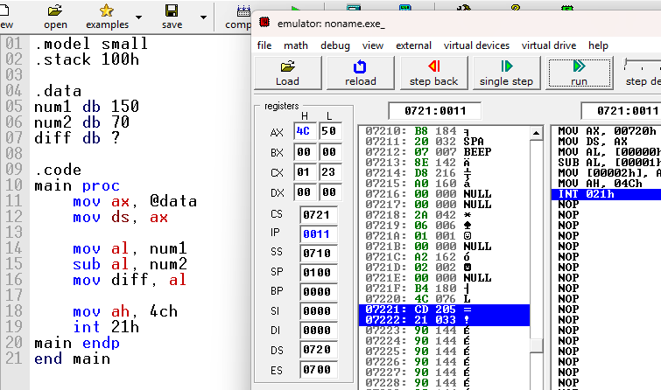
DEBUGGING:
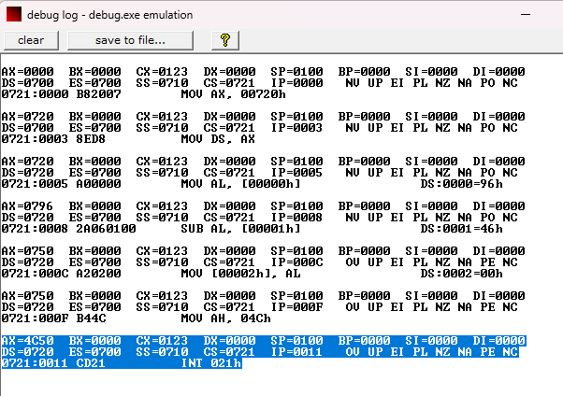
STEP:
- ax gets data segment address
- ds gets value from ax
- al = num1
- al = al − num2 =>subtraction result in al
- store al into diff memory
- ah = 4ch to prepare exit
- int 21h => terminate program
FLAGS:
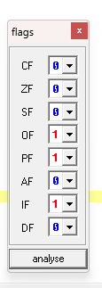

TASK#4
Write a program that multiplies two unsigned numbers using MUL and two signed numbers using IMUL.
CODE:
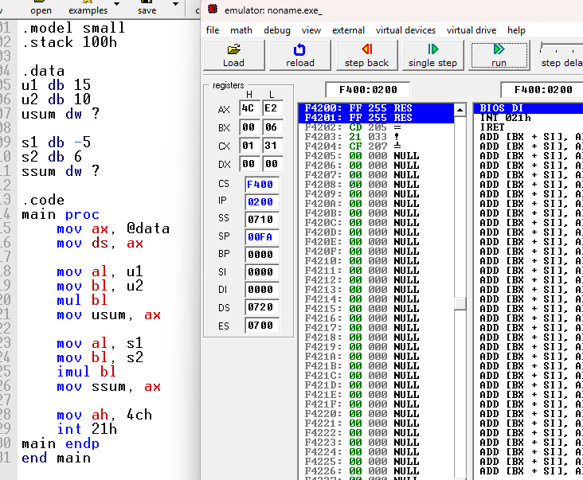

DEBBUGGING:
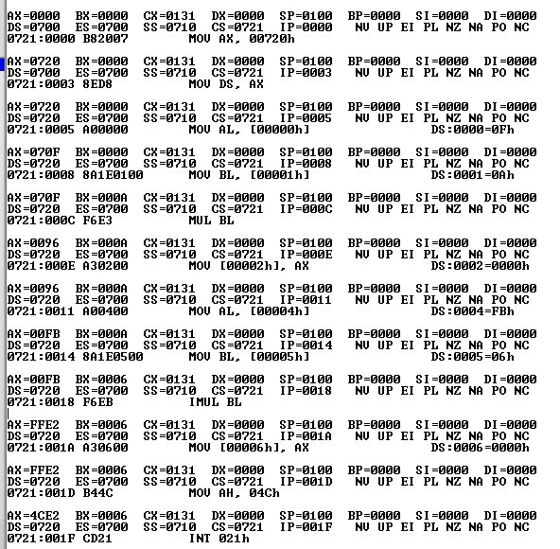
STEPS:
- ax gets data segment address
- ds gets value from ax
- al = u1
- bl = u2
- mul bl => unsigned multiply result in ax
- store ax into usum
- al = s1
- bl = s2
- imul bl =>signed multiply result in ax
- store ax into ssum
- ah = 4ch =>prepare exit
- int 21h =>terminate program

TASK#5
Develop a program that divides an unsigned number using DIV and a signed number using IDIV.
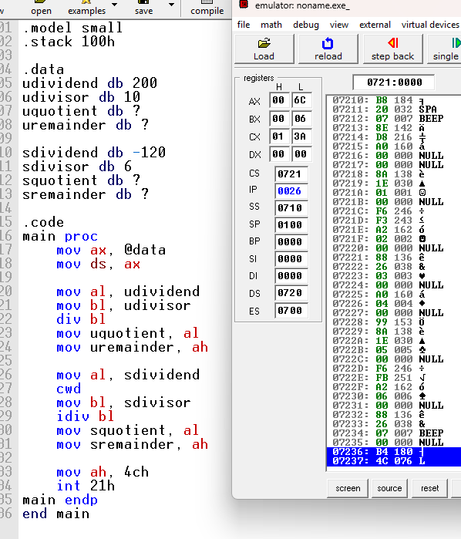
CODE:

DEBUGING:
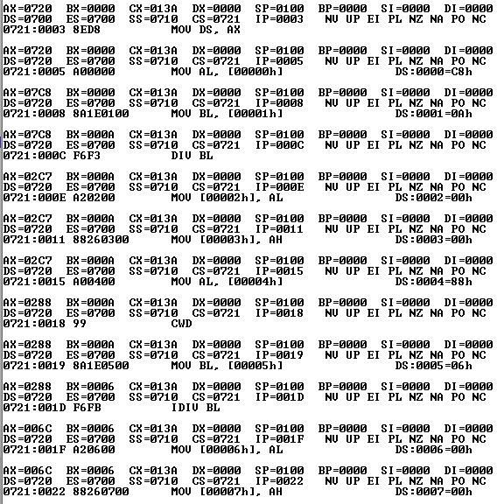
STEPS:
- ax gets data segment address
- ds gets value from ax
- al = udividend
- bl = udivisor
- div bl => unsigned divide, quotient in al, remainder in ah
- store al into uquotient
- store ah into uremainder
- al = sdividend
- cwd =>extend al into ax for signed division
- bl = sdivisor
- idiv bl =>signed divide, quotient in al, remainder in ah
- store al into squotient
- store ah into sremainder
- ah = 4ch =>prepare exit
- int 21h =>terminate program
FLAGS:
